**UPLOAD IMAGE TO IBM CONTAINER REGISTRY**

|  |  |
| --- | --- |
| **TEAM ID** | **PNT2022TMID22972** |
| **PROJECT NAME** | **SKILL AND JOB RECOMMENDER** |

Create a Kubernetes cluster

* Sign in to your [IBM Cloud Dashboard](https://cloud.ibm.com/dashboard/apps/?cm_sp=ibmdev-_-developer-tutorials-_-cloudreg).
* Open **IBM Kubernetes Service**.

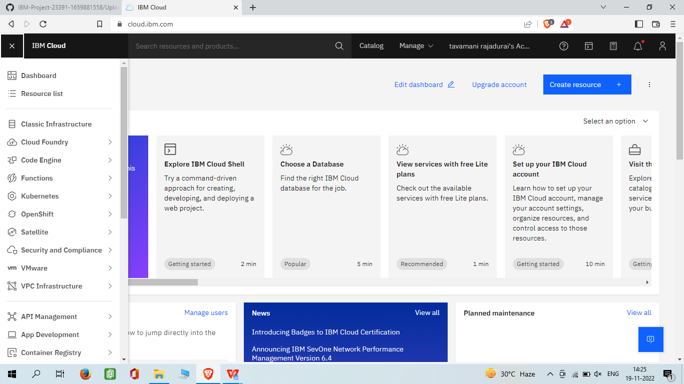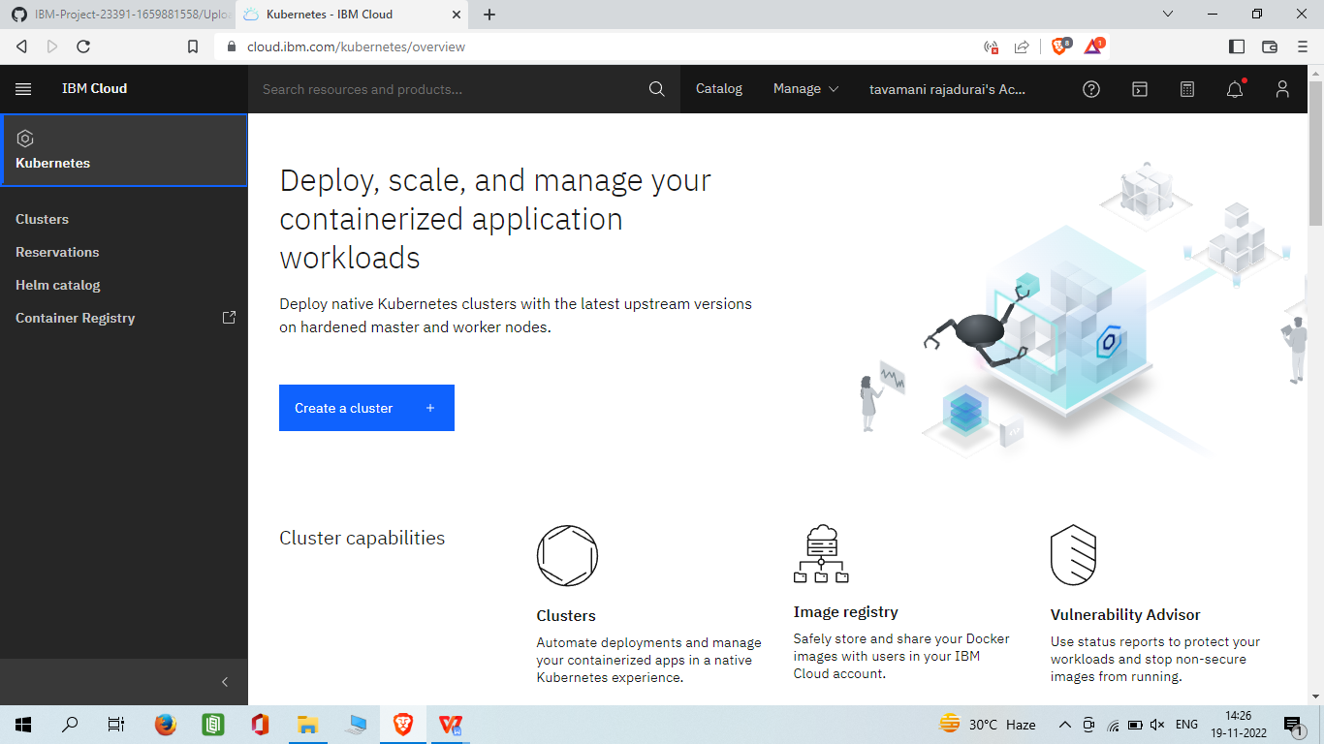

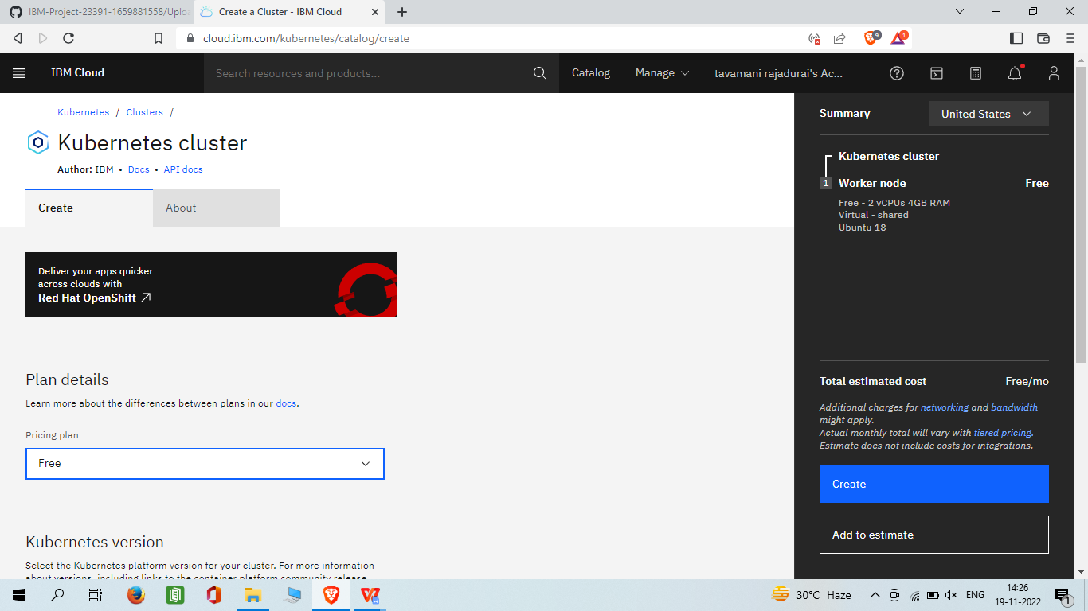

* Click on the **Worker Nodes** tab to note the cluster's Public IP.

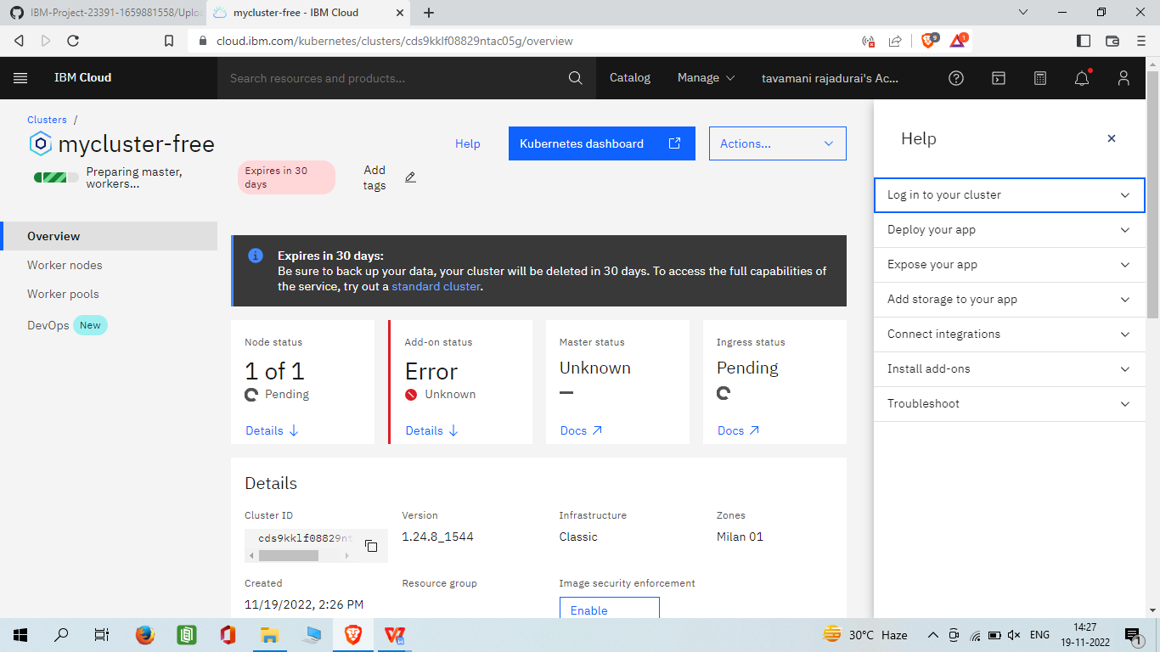

Containerize your Flask application

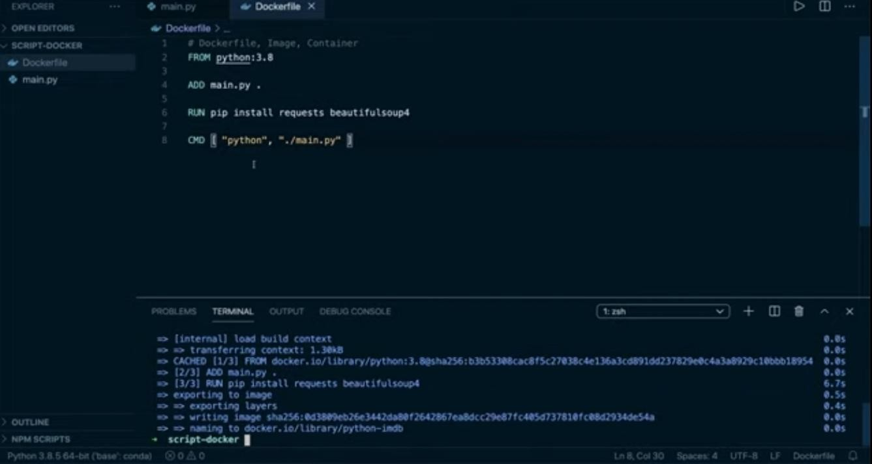

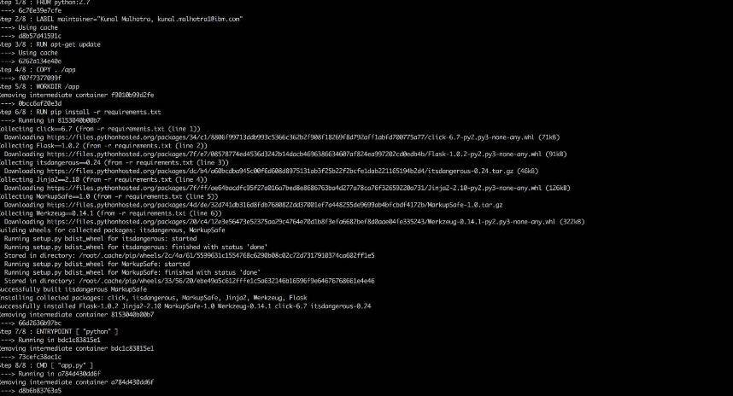

Create configuration files for Kubernetes

# deployment.yaml

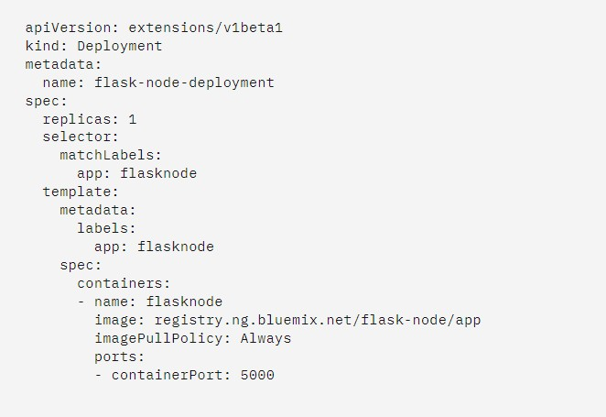

**service.yaml**

